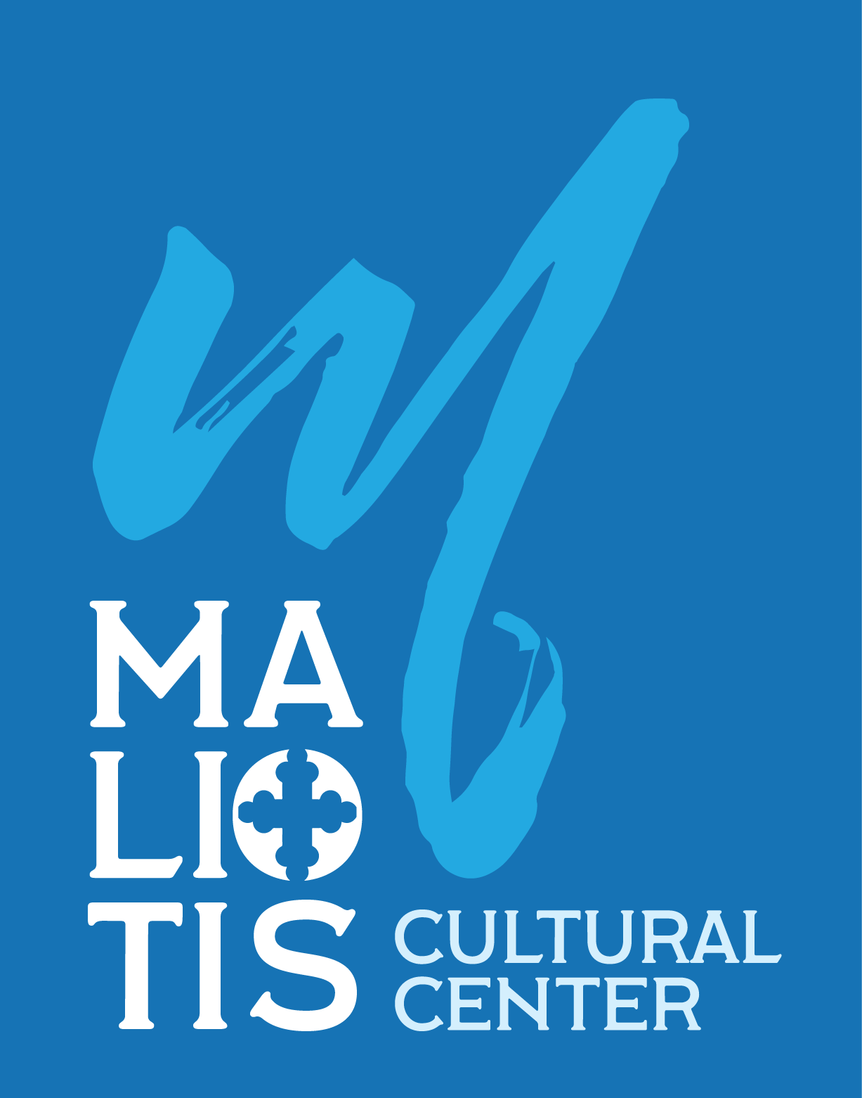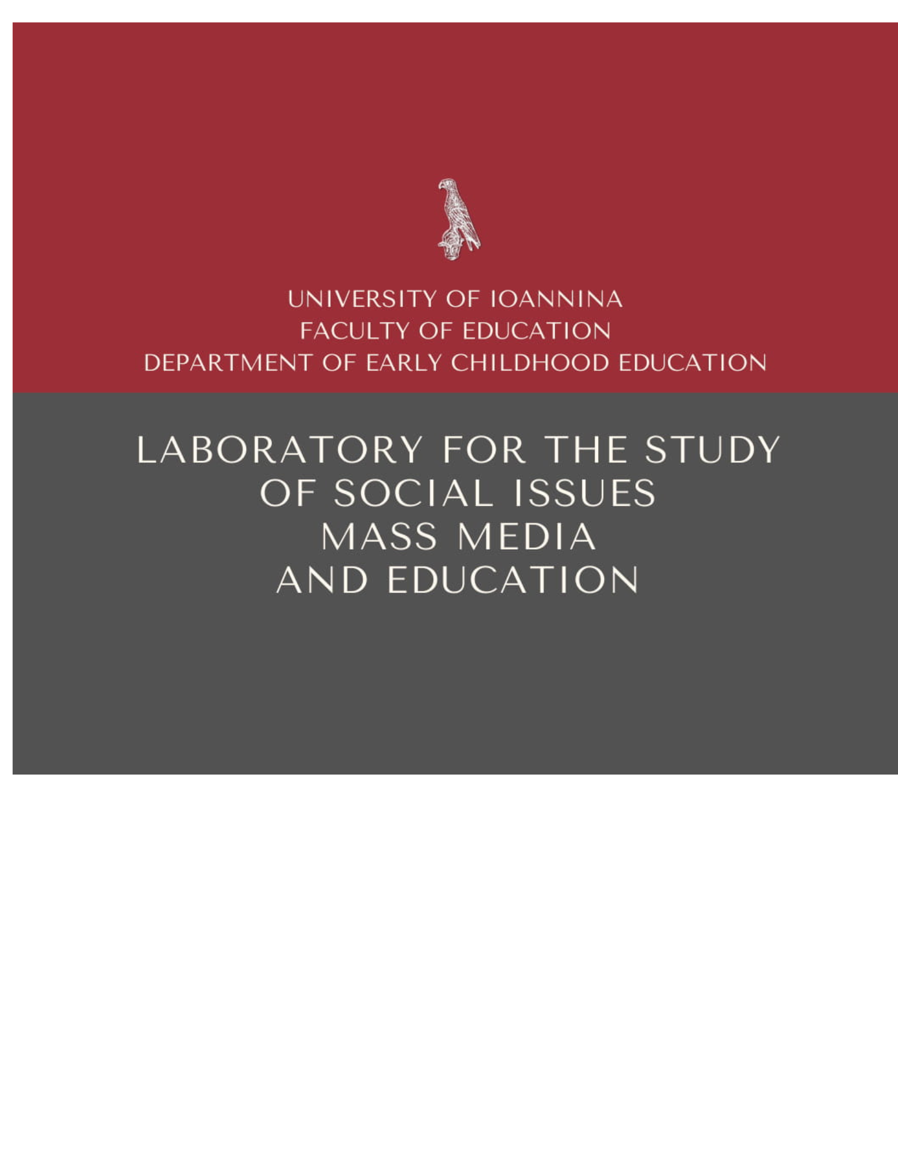

Greek Language in Times of Crisis:

International Symposium & Workshop

at the Maliotis Cultural Center

on the challenges and the future of the online era

❦

The Maliotis Cultural Center of Hellenic College Holy Cross, in collaboration with the Social Issues, Mass Media, and Education Studies Laboratory (S.I.M.M.E.S.L.) of the Department of Early Childhood Education of University of Ioannina, is organizing a major academic event highlighting the role of the Greek language within today’s new digital, social, and geopolitical realities.
This event is the International Symposium titled “The Greek Language Online in Times of Crisis: Challenges & Prospects,” which will take place on May 8 and 9 in Brookline, Massachusetts, with simultaneous online broadcasting. The Symposium is being carried out with the participation of Hellenic College Holy Cross, the Center for Hellenic Studies at the University of Chicago, the Digital Innovation Lab in Theology and Culture at Aristotle University of Thessaloniki, and the Laboratory of Strategic Communication and Media at the University of Piraeus.
Scholars and researchers from Harvard University, Université de Montpellier Paul-Valéry in France, Northeastern University in Boston, and other collaborating institutions from the United States and Europe will also take part. The collaboration of leading universities, centers, and research laboratories underscores the international scope and high academic caliber of this event.

With the participation of distinguished professors and researchers from the U.S. and Europe, the International Symposium at the Maliotis Cultural Center aspires to become a reference point for the global dialogue on language as a tool of culture, democracy, and innovation in the 21st century.

At a time when information becomes a field of influence and artificial intelligence radically reshapes public discourse, the Symposium will examine the dynamics of the Greek language in the digital environment: shifts in meaning during periods of crisis, the relationship between language and the media, strategies of political communication, and new prospects for education and Greek-language learning in the diaspora.

In addition, the Symposium’s workshop carries special significance, as it intentionally turns its focus toward the next generation. Its aim is to capture and amplify the voice of young researchers of the Greek diaspora, who experience and redefine the Greek language daily within today’s digital and multilingual environment. Students and early-career researchers from universities in Greece and abroad will participate, reinforcing the international character of the event and creating a dynamic network of collaboration that connects Greece with its diaspora. In this way, the Symposium does not limit itself to a theoretical assessment of current developments but consciously invests in the new generation that is shaping the future of the Greek language in the digital world.

The organizational direction of the Symposium is overseen by Ms. Chrysoula Kourkounti, Executive Director of the Maliotis Cultural Center of Hellenic College Holy Cross, while the academic supervision of the program is led by Professor Nikoletta Tsitsanoudis-Mallidis, Linguist and Dean of the School of Education at the University of Ioannina.

❦

